See attached file ‘mockup’ for reference of index/buy page. 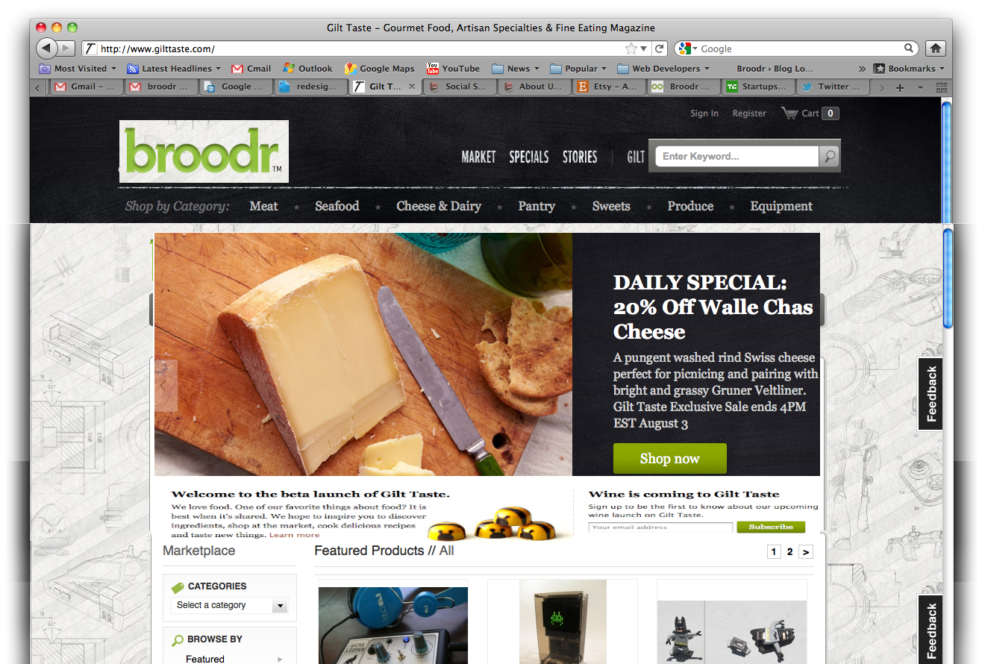

HEADER/NAV:

See gilttaste for style – only difference is that search bar will be to right of ‘buy sell about blog’ (gilttastes version of market special stories gilt).

NOTE We want the new header version to have a different stylized background, with the current background we have in place simply pushed down right below. A black dark texture – similar to gilttaste without an actual encapsulated nav bar.

BUY PAGE – aka default/Homepage:

Click through wheel/carousel (LIKE ON GILT TASTE). Note We would want about 3 or 4 slides dynamic as we discussed, editable through the admin… We only want this to appear on the homepage/buy url – NOT subsequent pages or drill downs into categories. Please let us know if you encounter anything in our code that makes this particularly hard, we may need to restructure how browsing works on the backend

Note, we would like a section underneath (like on gilttaste) where we can have text and a email submit – exactly the same structure and style.

ABOUT PAGE:

Restyle look and feel of about page:

-Make text bigger and bolder, more line spacing

-Make header text slightly larger

-Right now all the text is loaded from the DB and set through the admin. Headers are h1 tags and paragraphs are p tags. If h2 or different number tags would be better to use than this to avoid impacting global css rules, let us know and we can make the changes to the text.

We will send you a Banner similar to the one below for the top of the ABOUT page (right under nav bar) – this is from the kickstarter homepage for an example:

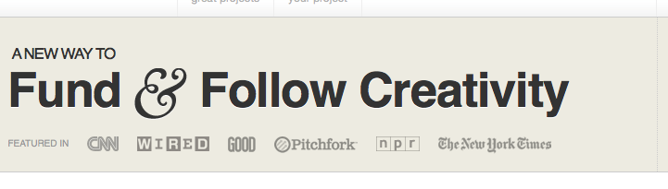

“Discover and Purchase the coolest new stuff. Products Featured In: The NY Times, Thrillist, Gizmodo, Technabob, TheSwagMag.com, Oh Gizmo!, DVICE

NOTE: This is the copy that we’re going to put in the database – just use the same dynamic way that it gets pulled in. We’re not asking you to put any of the copy into the new pages.

Header: WTF is Broodr?

Text: Broodr is a new marketplace with hundreds of uniquely awesome products and inventions from entrepreneurs, hackers, makers, and mad scientists all over the world.

(To the right of the text – we will send you an attached/stylized (tech-looking) map with hot spots/pins indicating countries our sellers are in – usa, Canada, china, japan, Israel, germany, france, Australia, new Zealand, Thailand, Cyprus, Russia). – static image.

Header: Go Team!

Broodr was hatched by Jason Blanck in early 2010 - an inventor and entrepreneur himself, Jason found there was no viable marketplace to sell and promote his own ideas online. Couple that with a lot of coffee, Jason established this ideal marketplace for any seller or creative business in the same position. Picture on right.

Info on John.. mention deviceknit, similar shpeel. Picture on right.